Contents

Work more on libraries (templates) 1

1.Picture Laybrary 3

Views 4

Upload some pictures 5

Rating 5

Wiki page 15

Editing 17

Insert 17

App part / web part 19

Site page 22

Download 24

Class 7

# Work more on libraries (templates)

Eg.

1. Important spread sheet:

To add data which have many rows and columns

spread sheet=>give (Name)=>Choose Excel file

we need to start from the last class

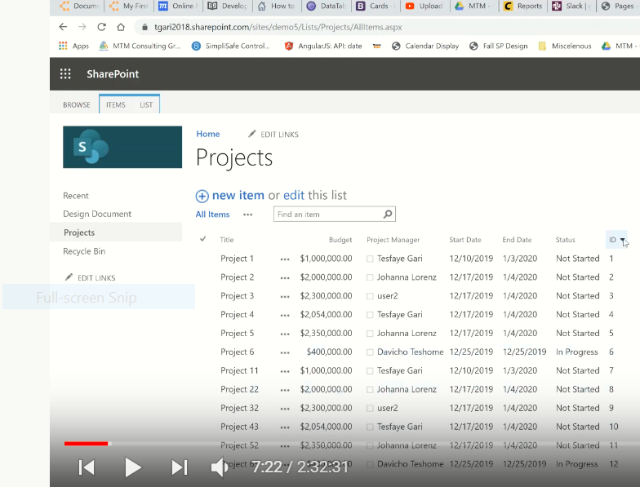

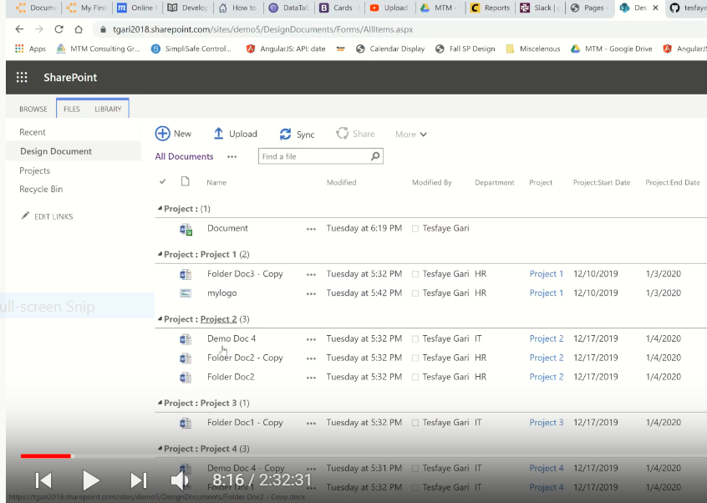

Look up 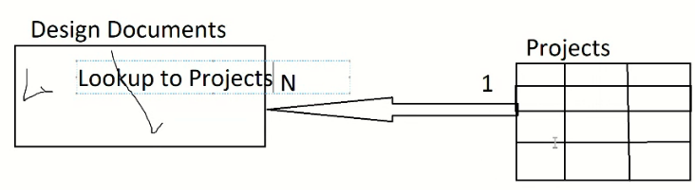

1.Picture Laybrary:Photo Gallery

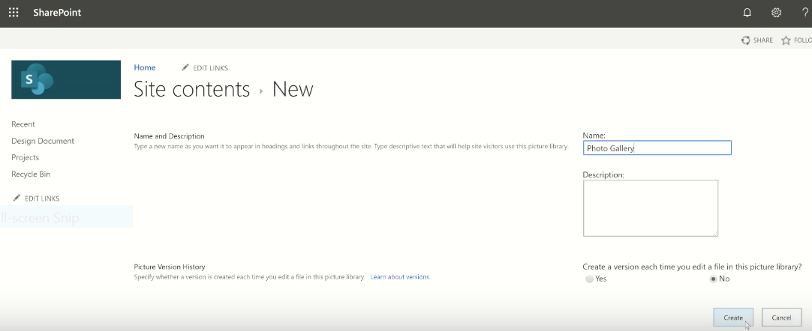

Created

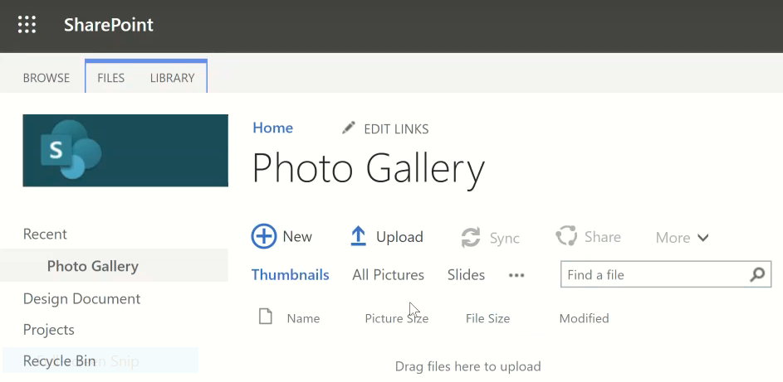

## Views

* [**Thumbnails**](https://eyos2011.sharepoint.com/sites/Demo/Photo%20Gallery/Forms/Thumbnails.aspx)
* [All Pictures](https://eyos2011.sharepoint.com/sites/Demo/Photo%20Gallery/Forms/Thumbnails.aspx)
* [Slides](https://eyos2011.sharepoint.com/sites/Demo/Photo%20Gallery/Forms/Thumbnails.aspx)

To know what is the opened page, we need to see at the end part of URL. For example.

<https://eyos2011.sharepoint.com/sites/Demo/Photo%20Gallery/Forms/Thumbnails.aspx>

From this link we have “**Thumbnails**” which is shows the view.

### Upload some pictures

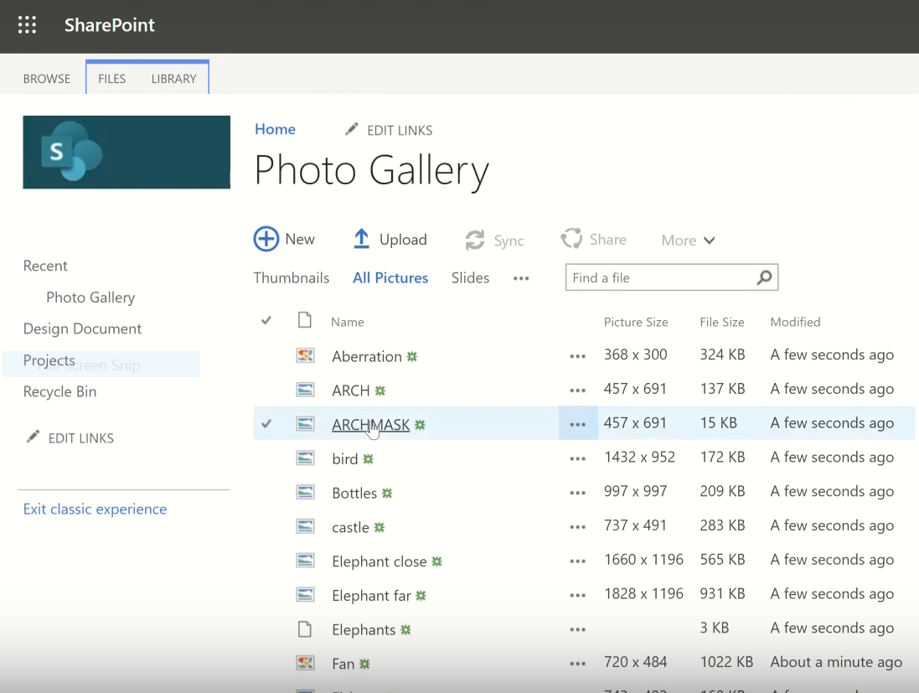

Rating**:**

To give like dislike for each pictures

Library=>Library setting=>Rating Setting=>yes=>Like

**Create Display View:**

**Create:**

Ellipse=>create new => standard view=>RateMyGallery

Thumbnel = 1

Name = #

Like= #

Dislike = #

Rating= # then ok

Keywork=>under columngood thing is

**Display:**

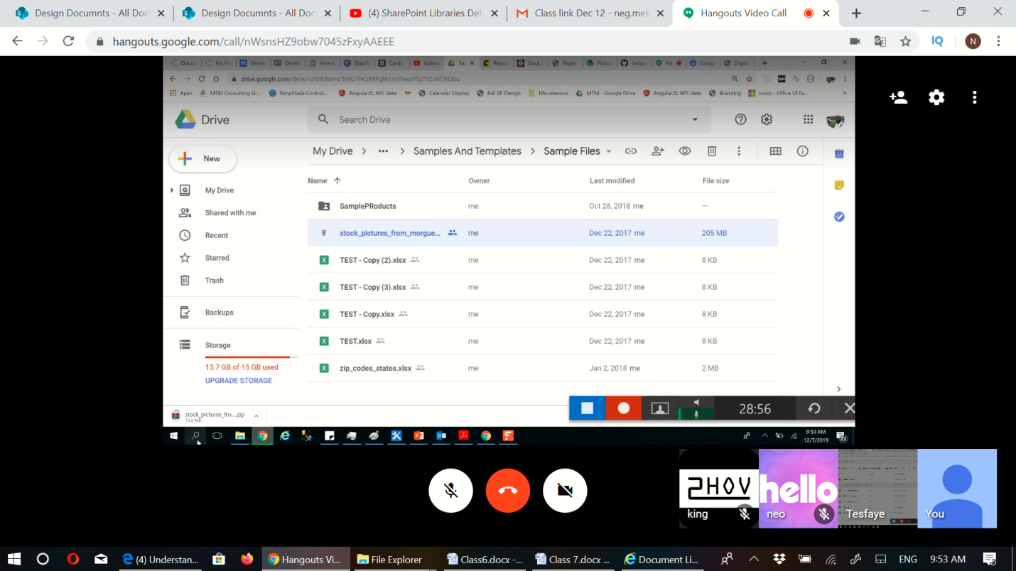

Download this picture

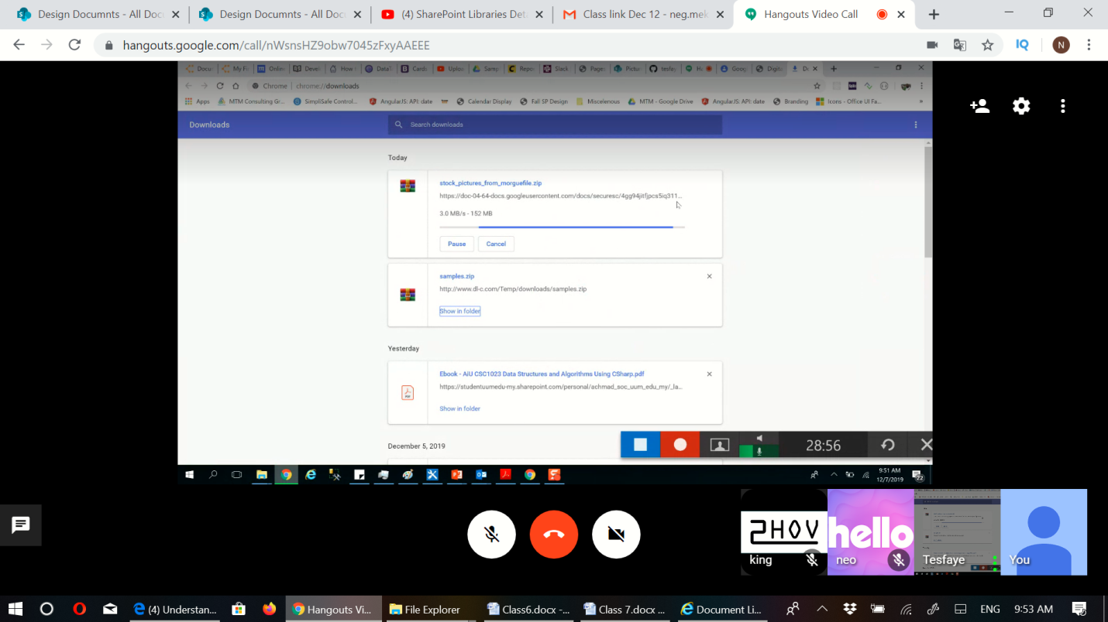

This biger

thembnial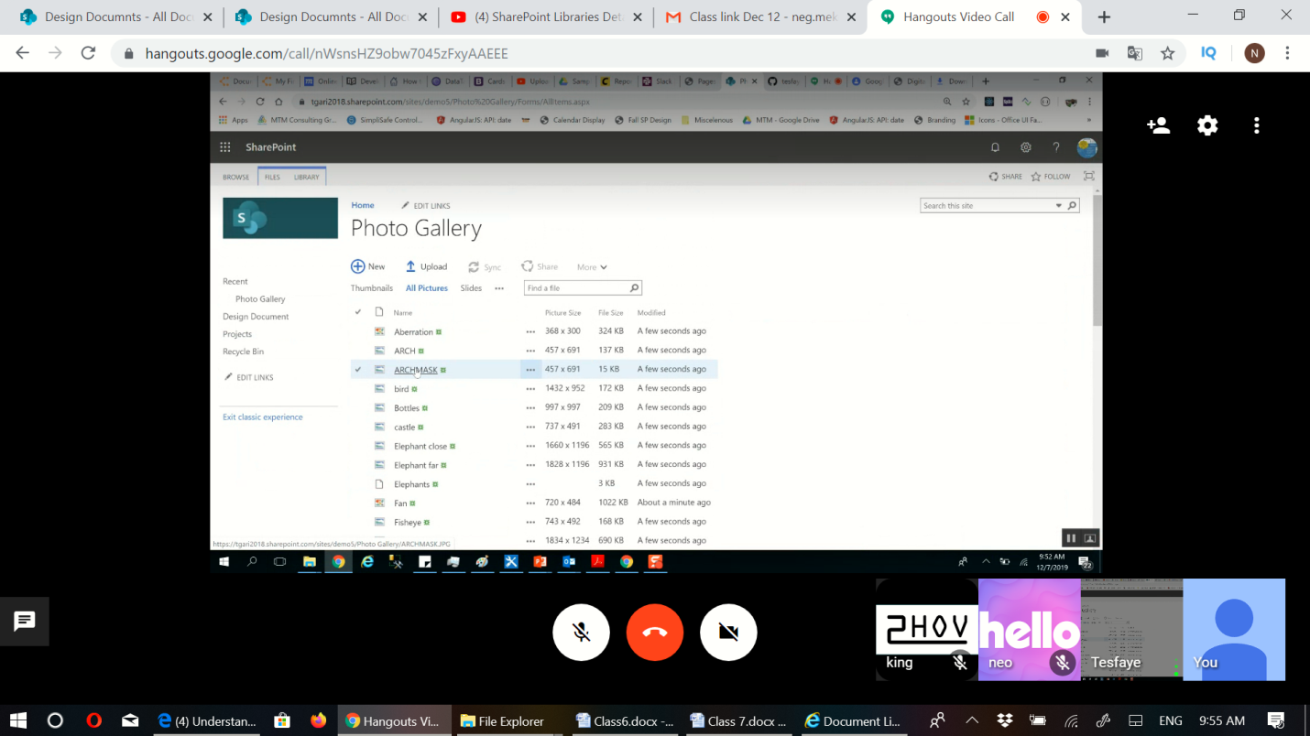

Thembnial

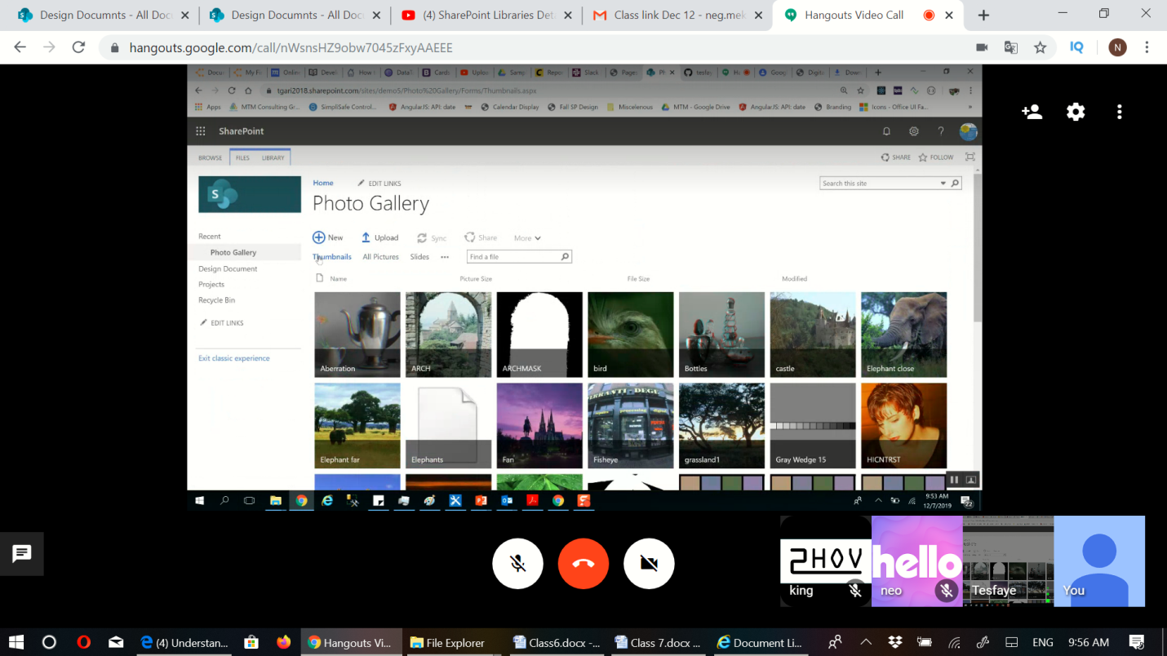

Rating

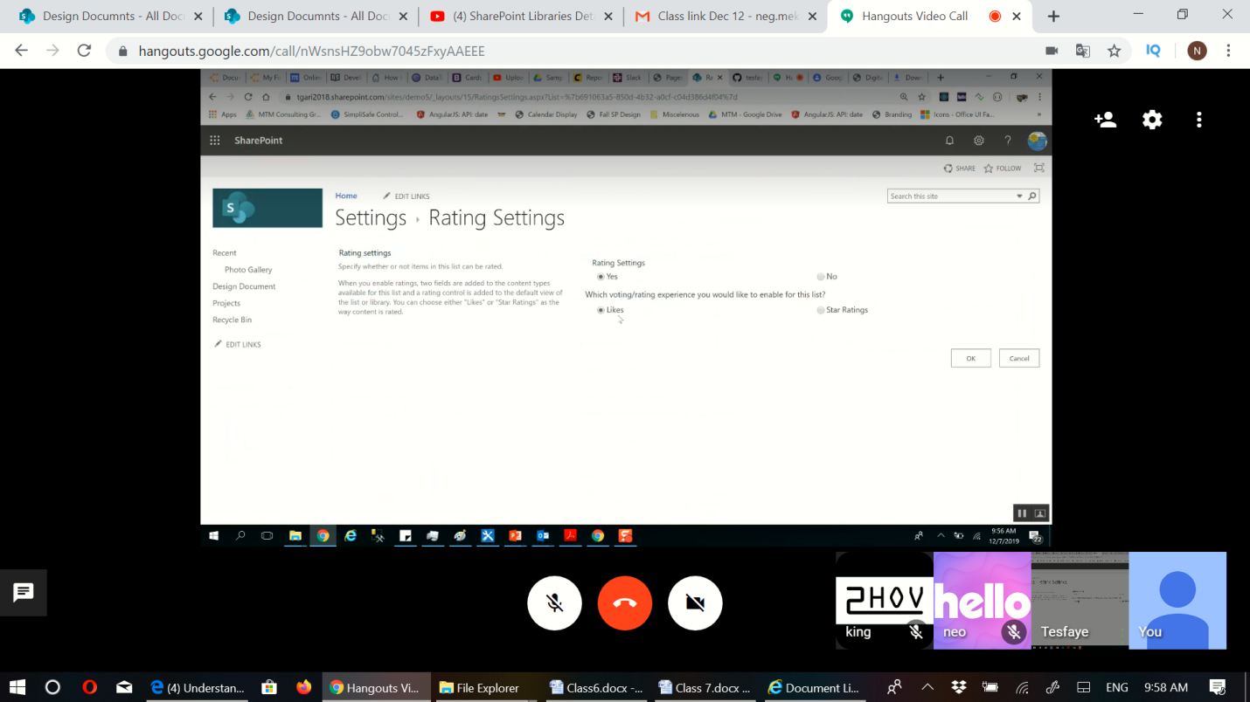

View

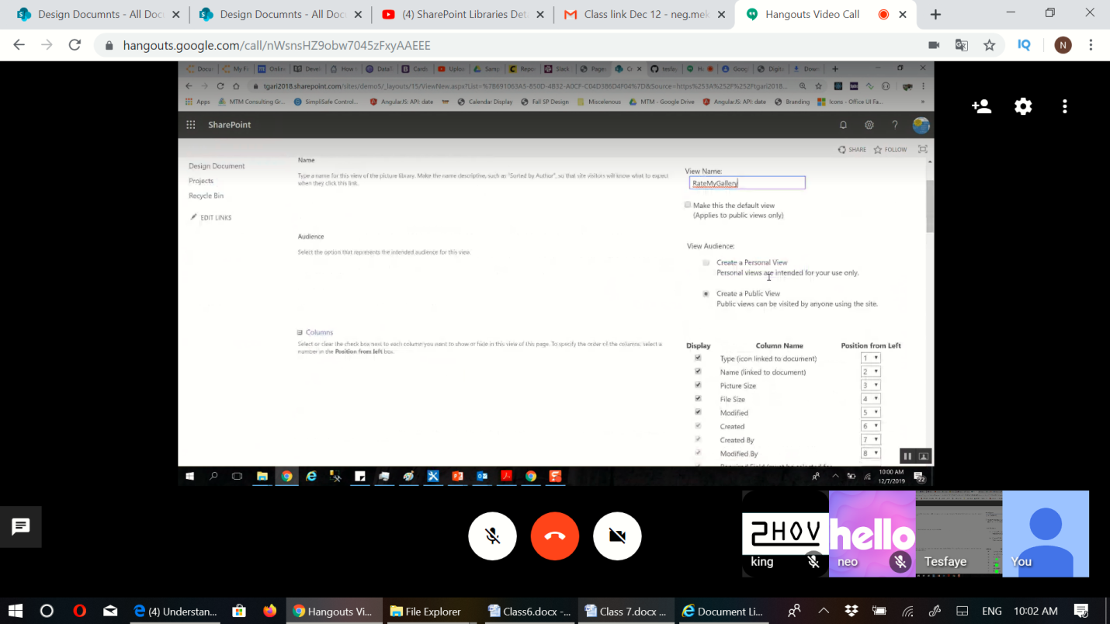

Themb

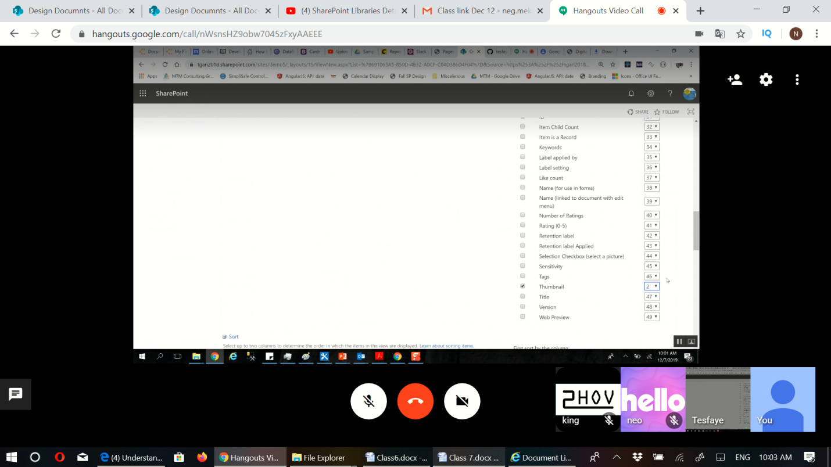

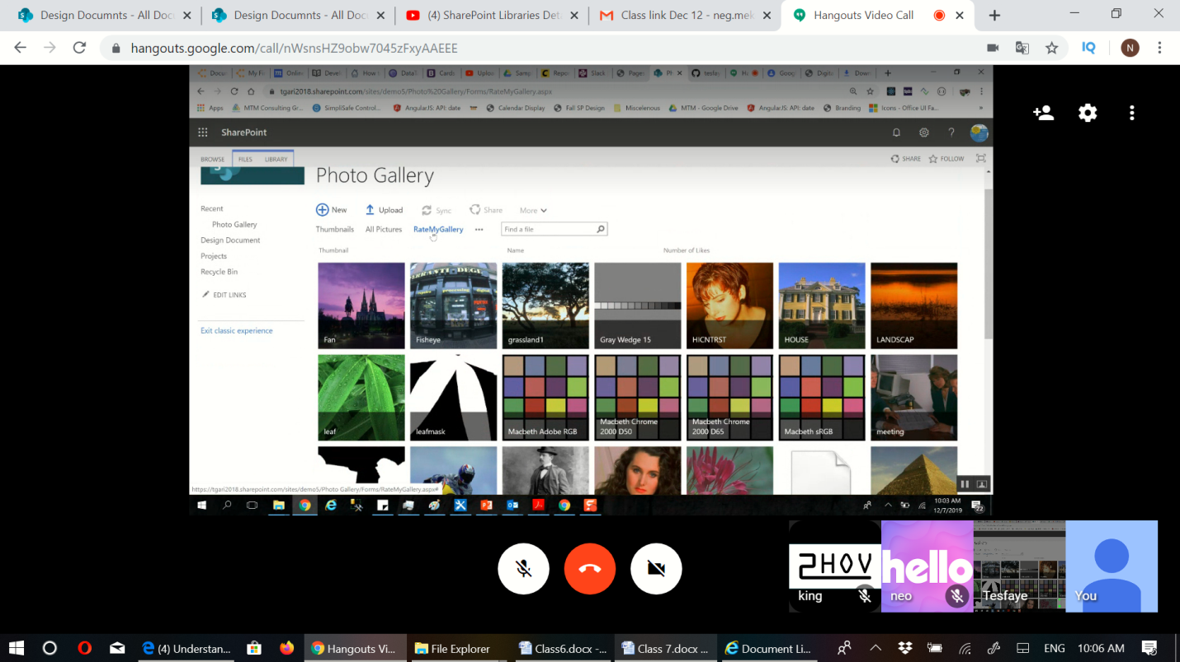

/////

AllItem

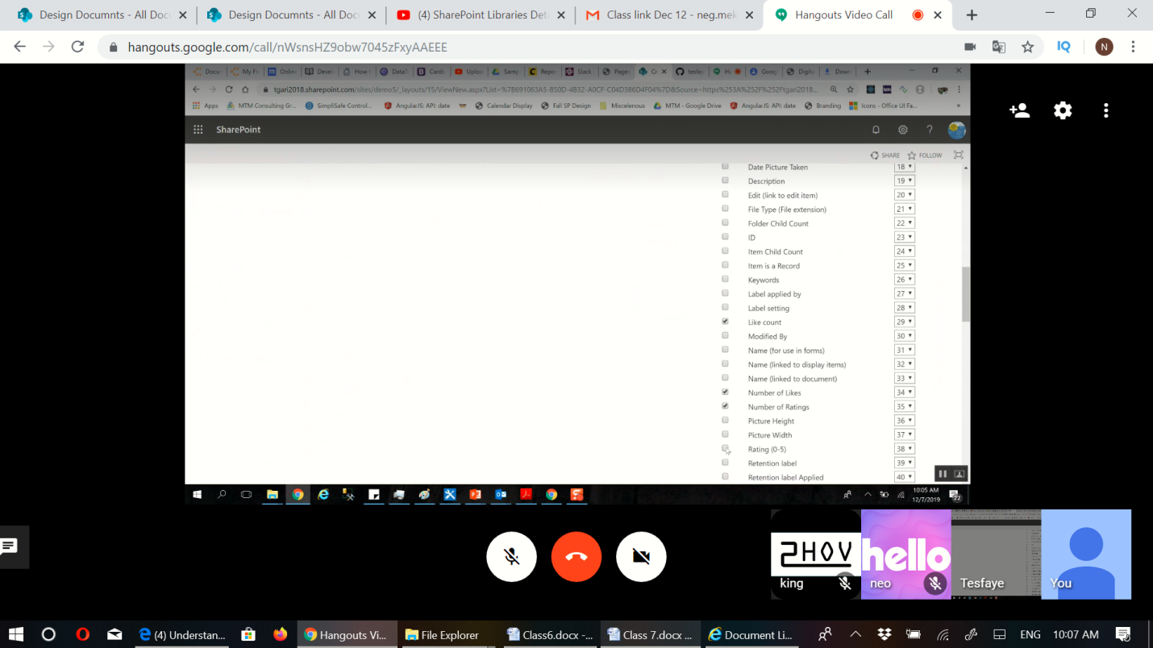

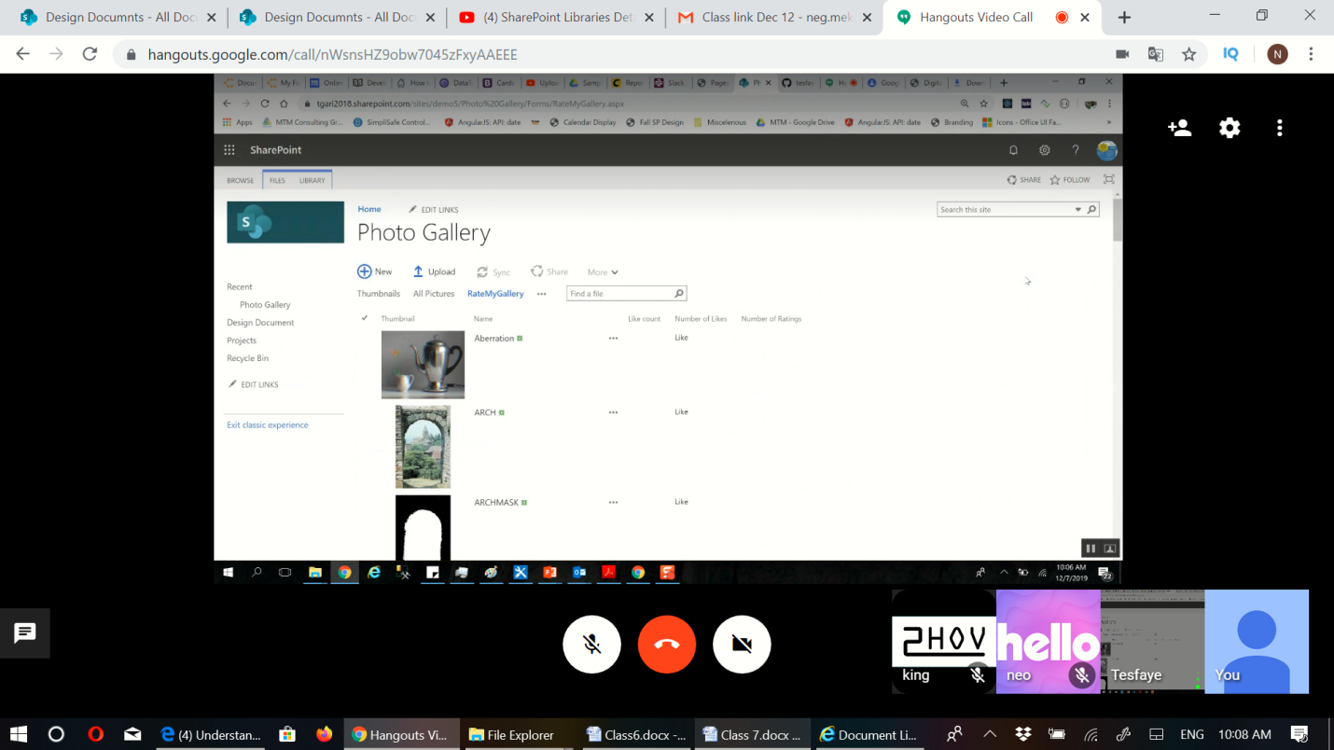

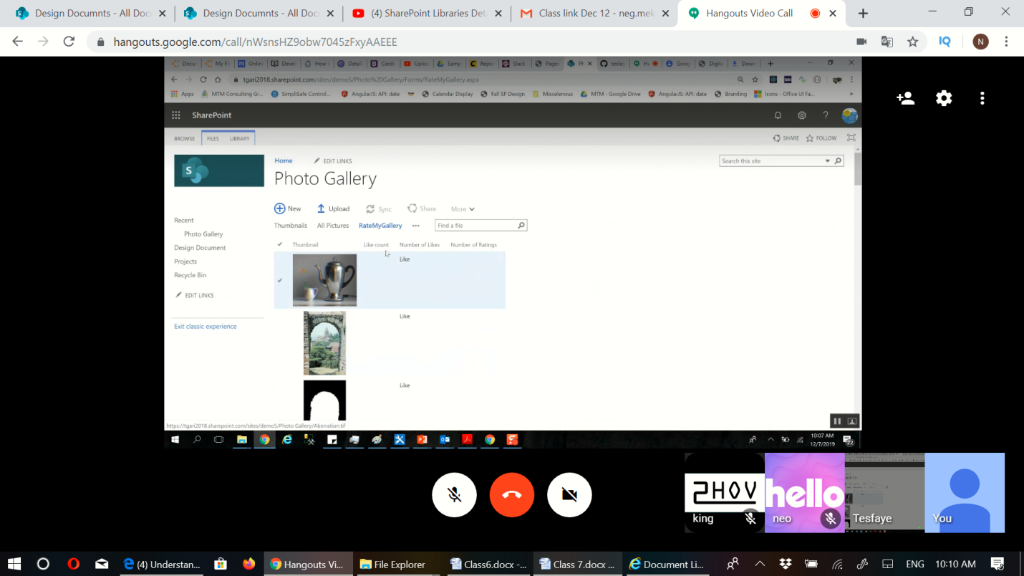

Like

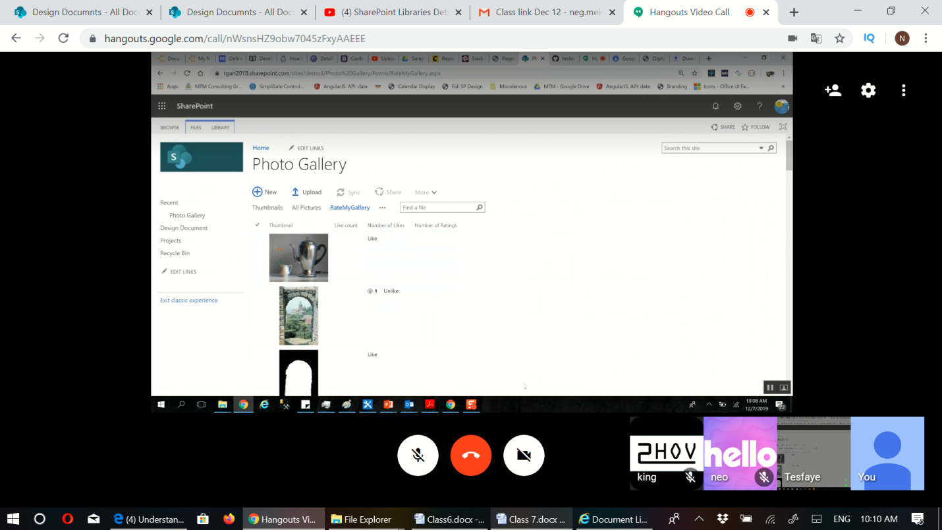

Goodle The remaining Templates

Link Templet

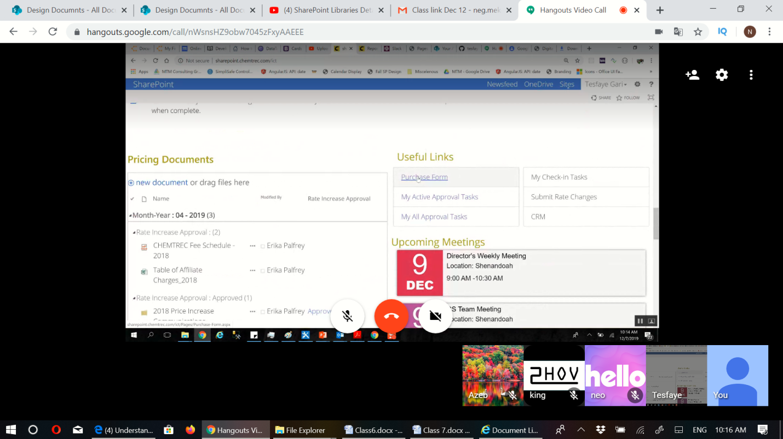

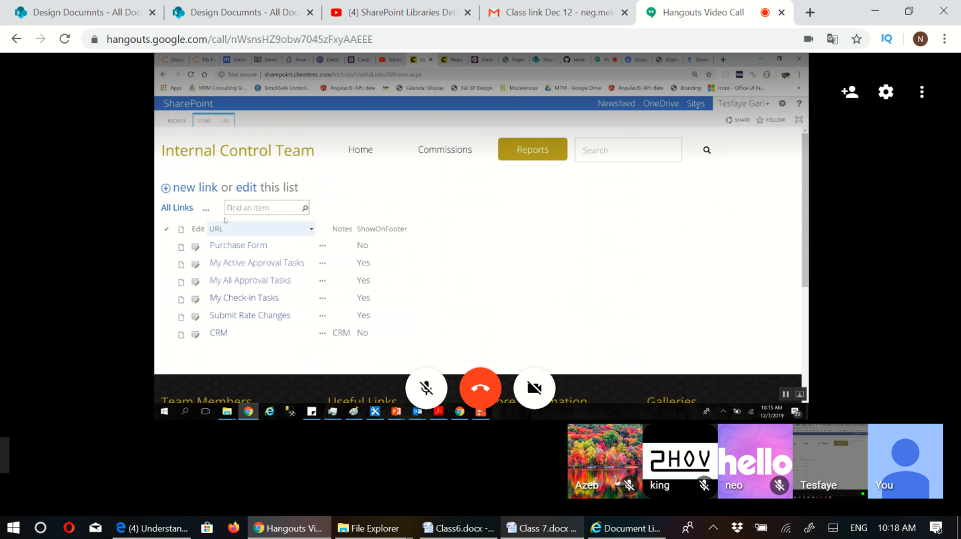

Eg

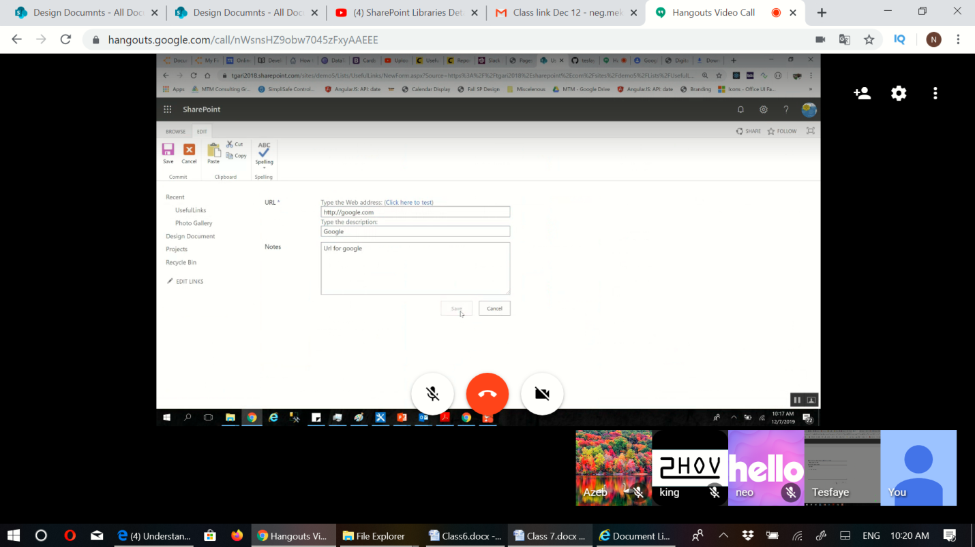

Add column

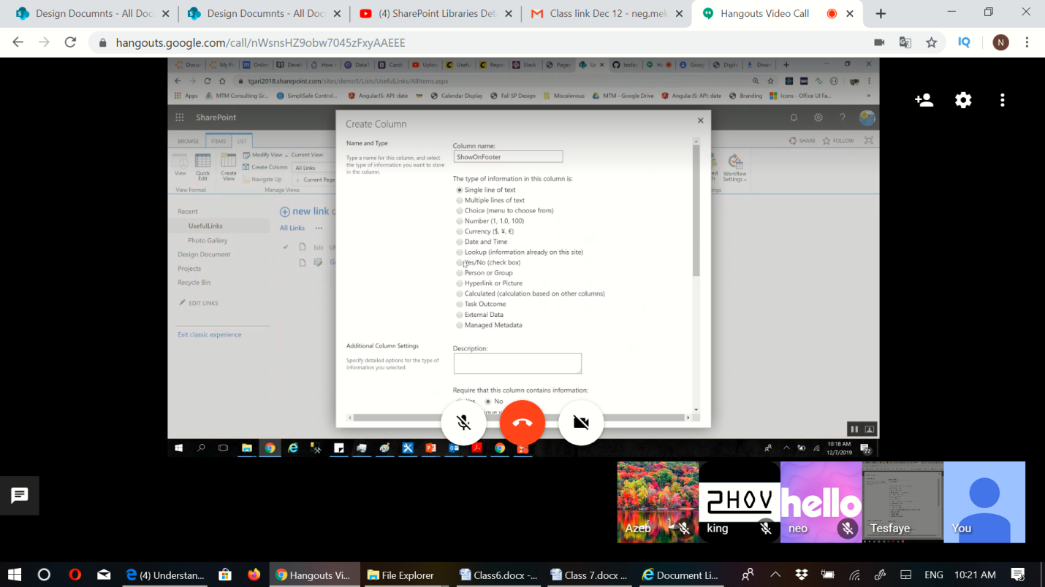

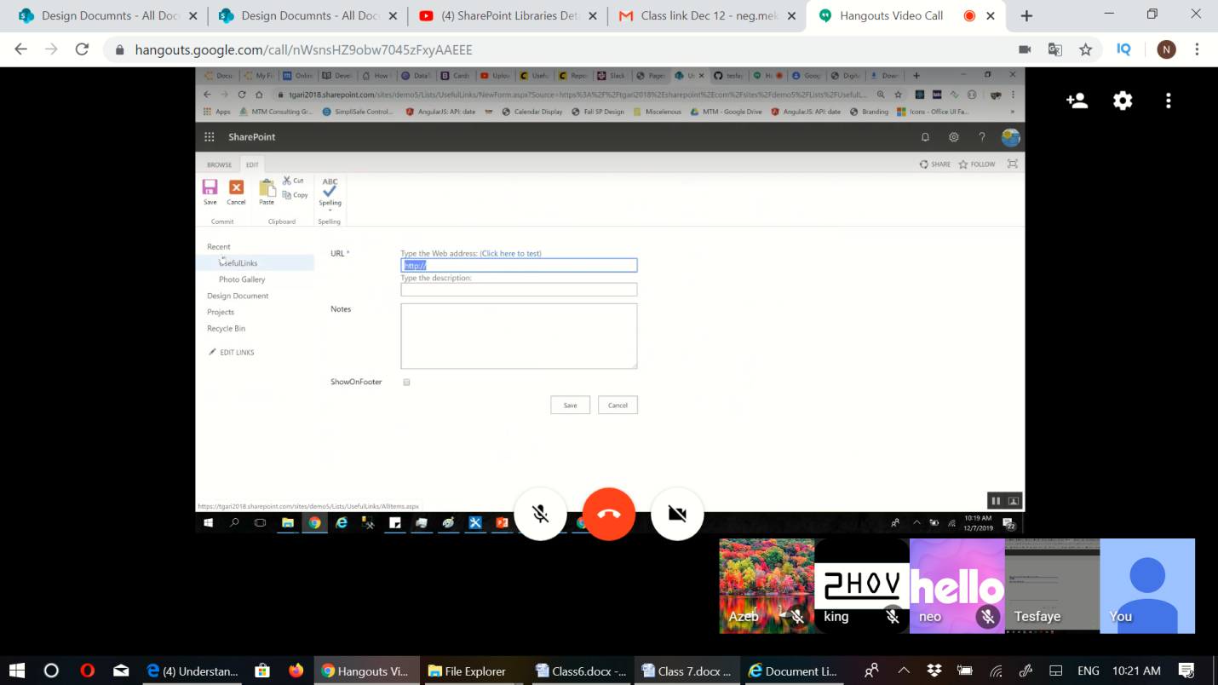

Sp dot Net =aspx=>browser

Html

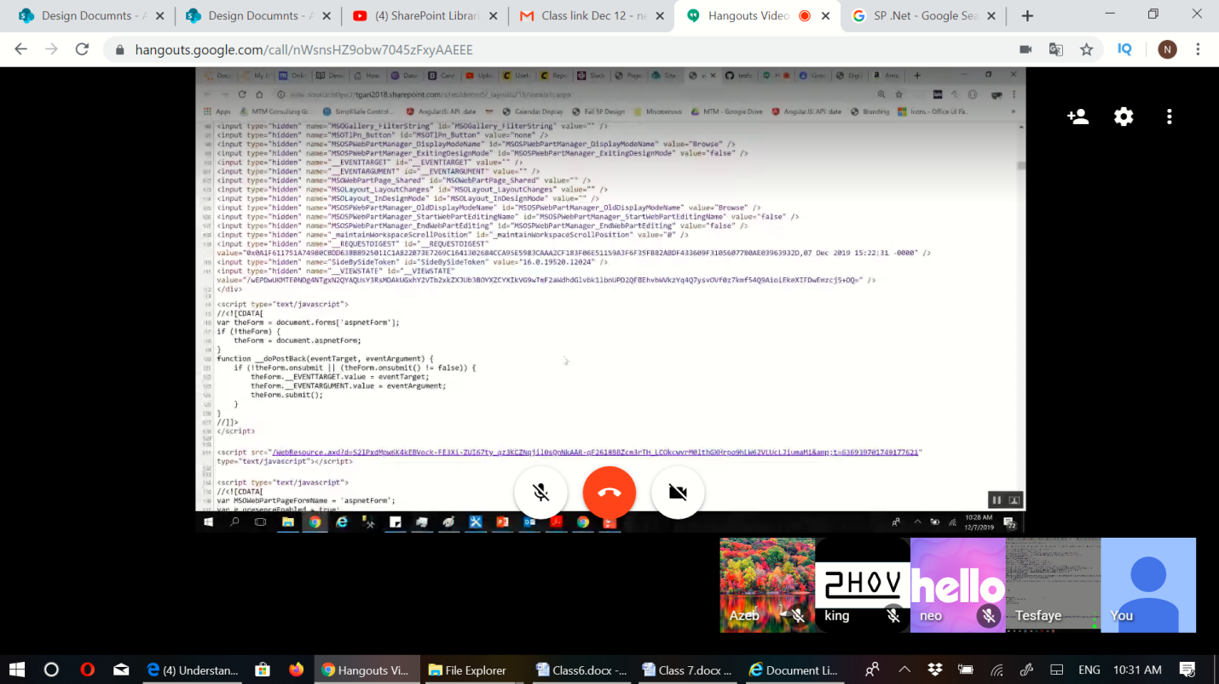

To create add page don’t use setting =>add page. Use

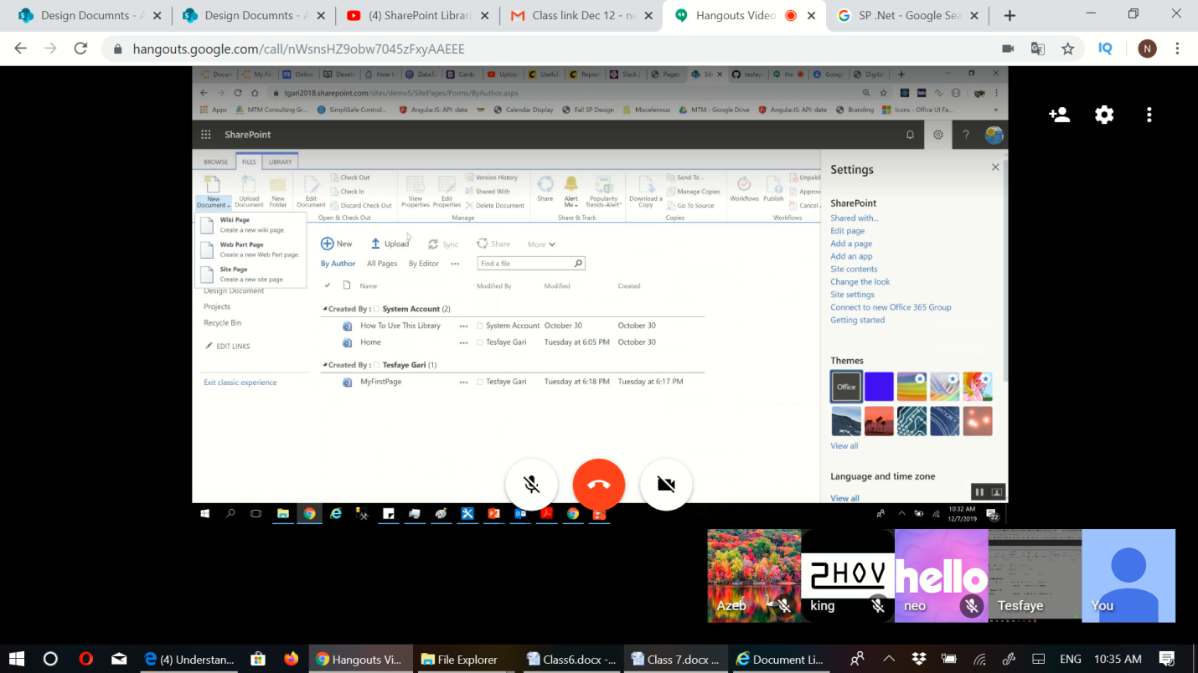

Wiki page, ..

Becare when we do on it

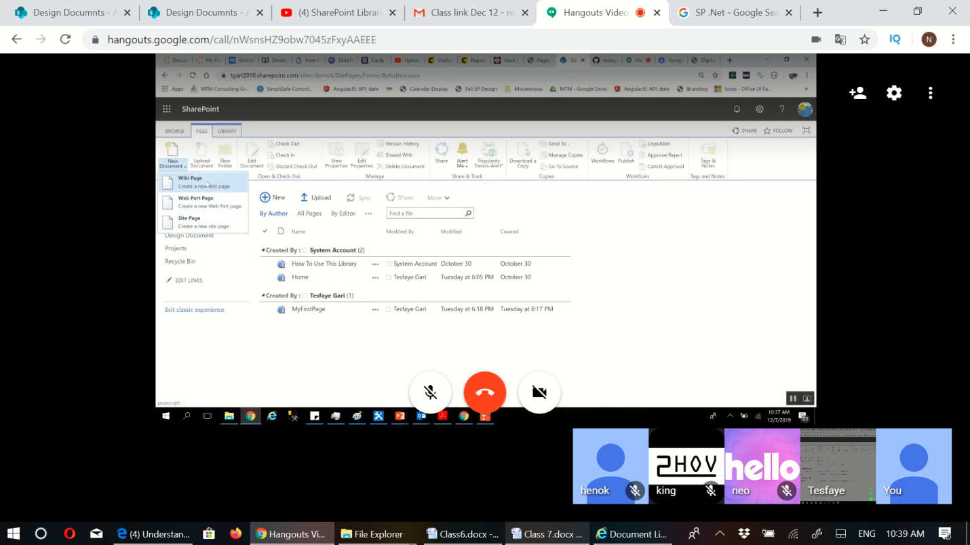

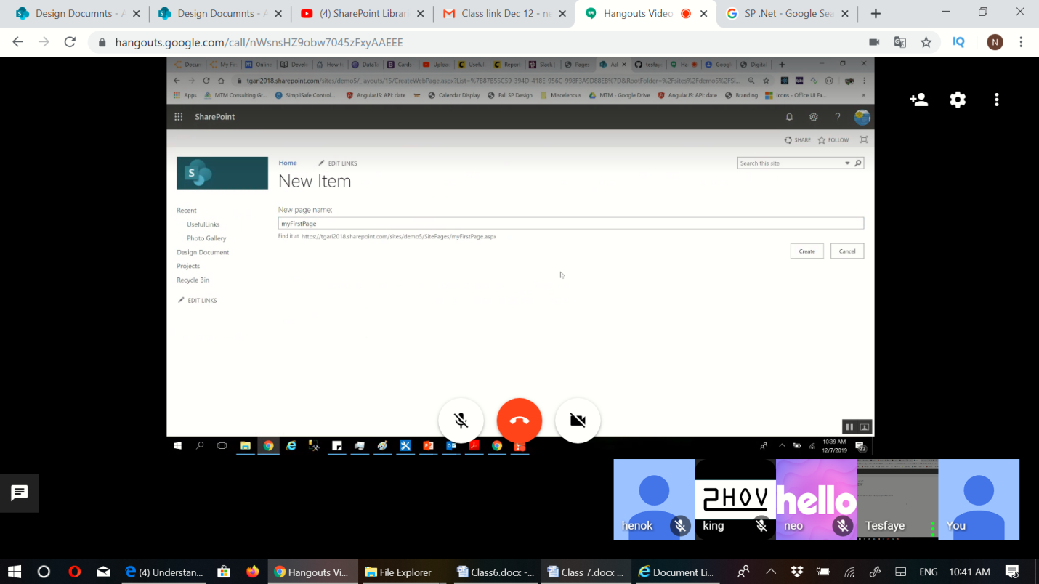

## Editing

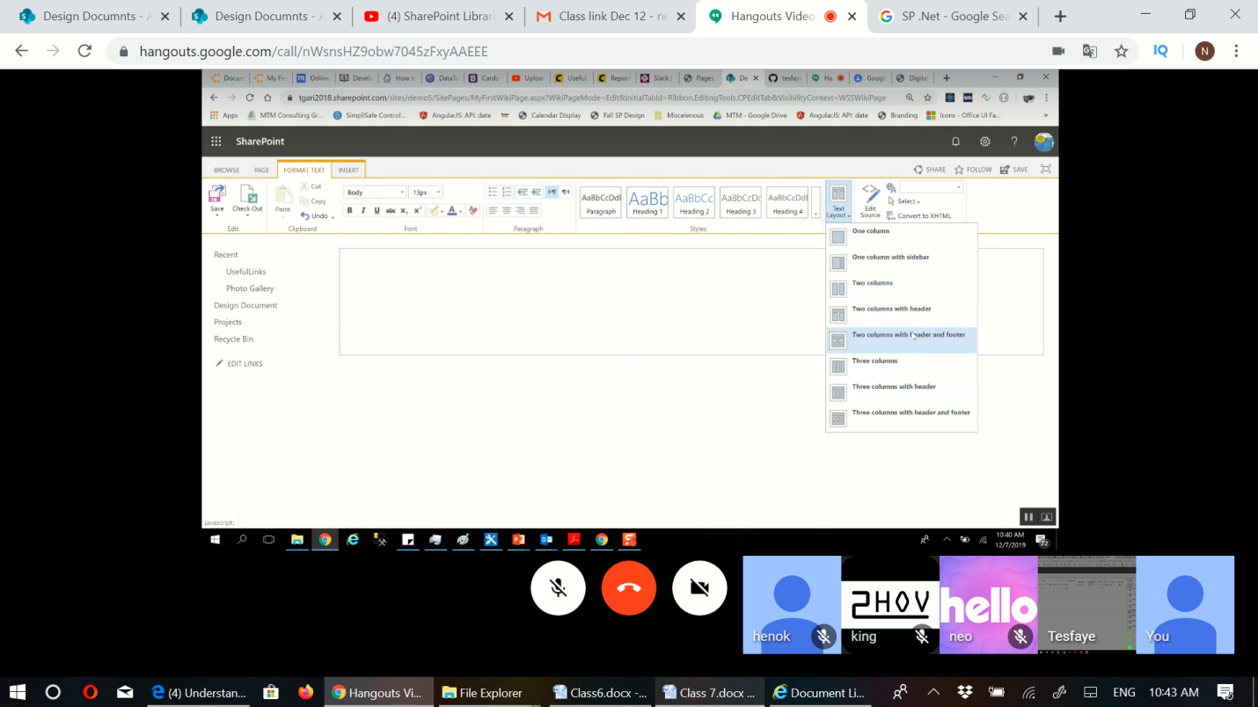

## Insert

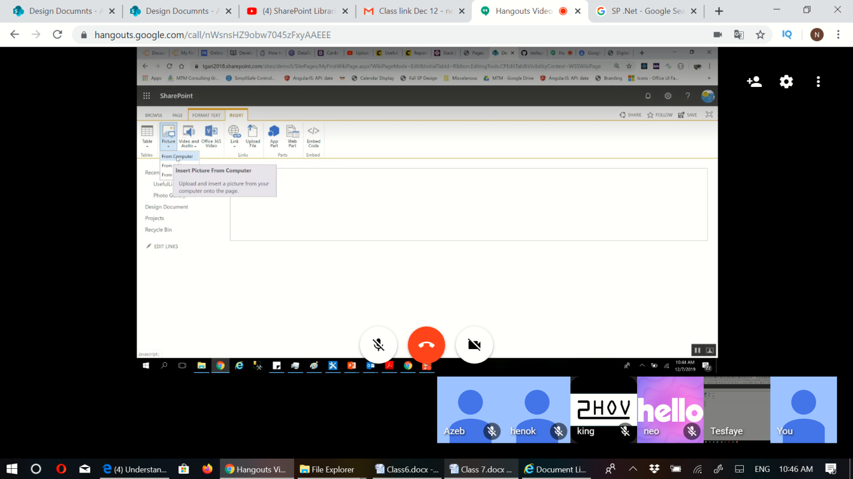

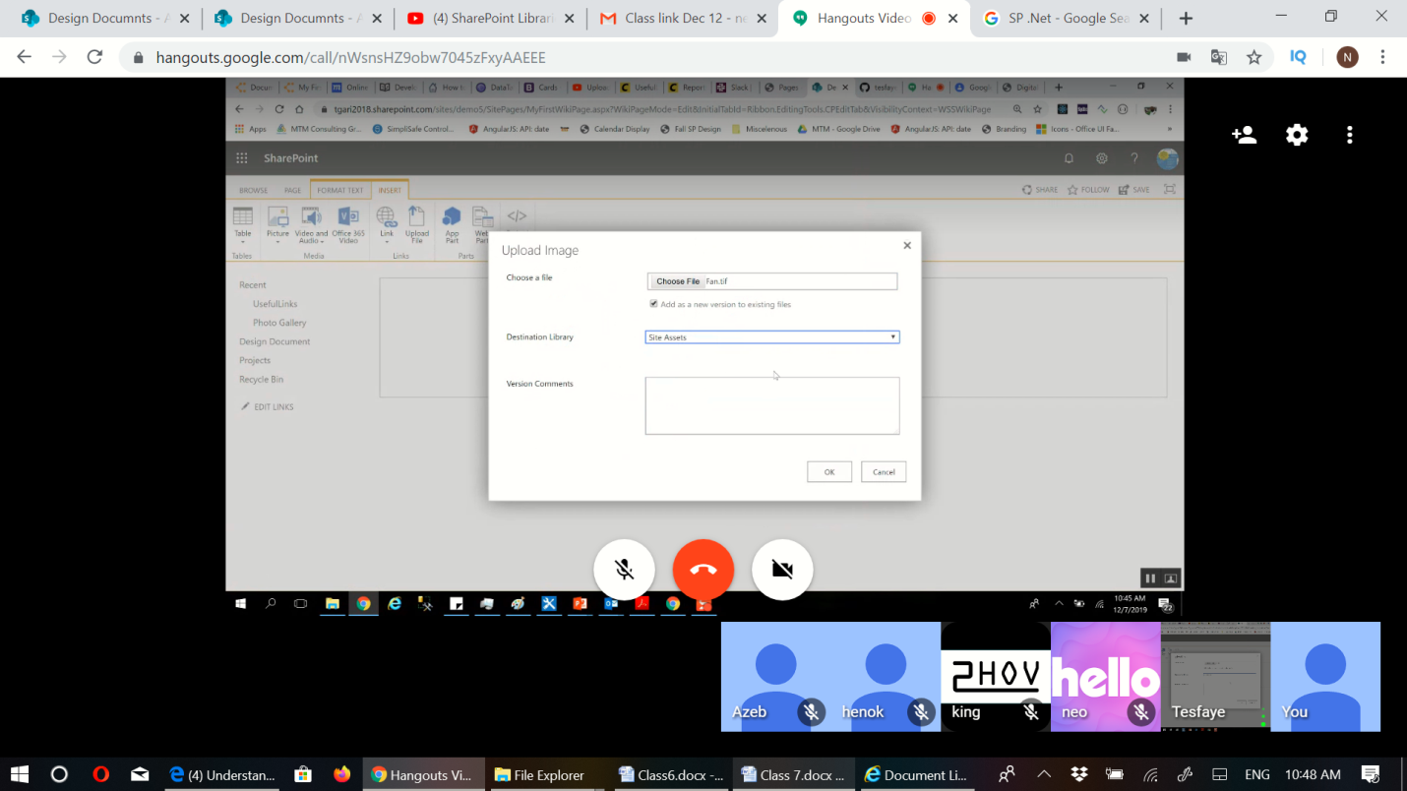

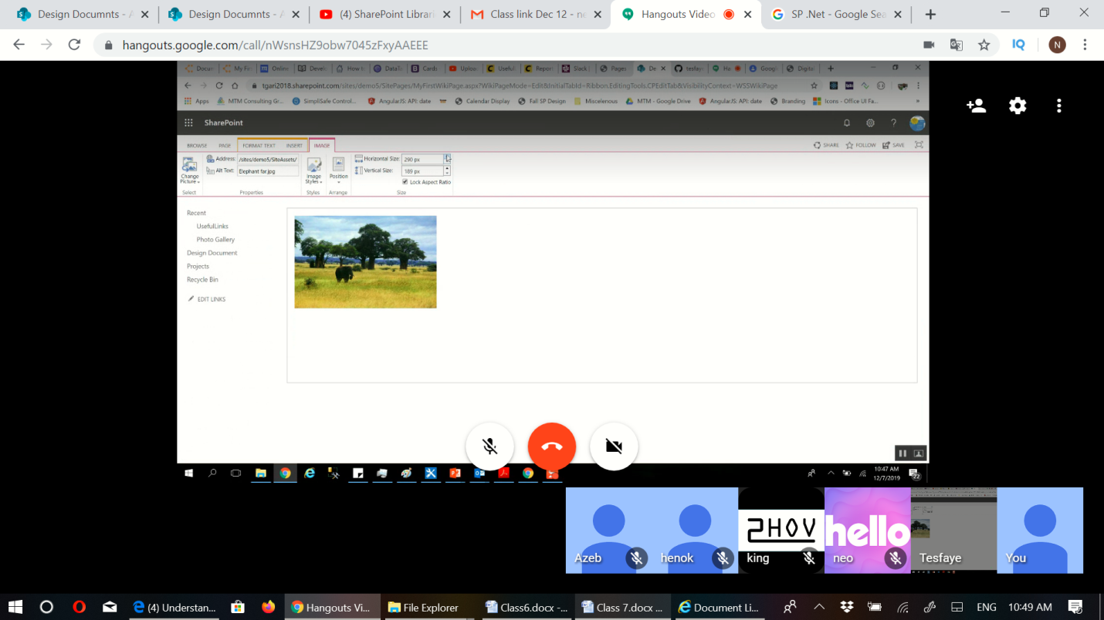

Aa and web part big eal in SharePoint

# App part / web part

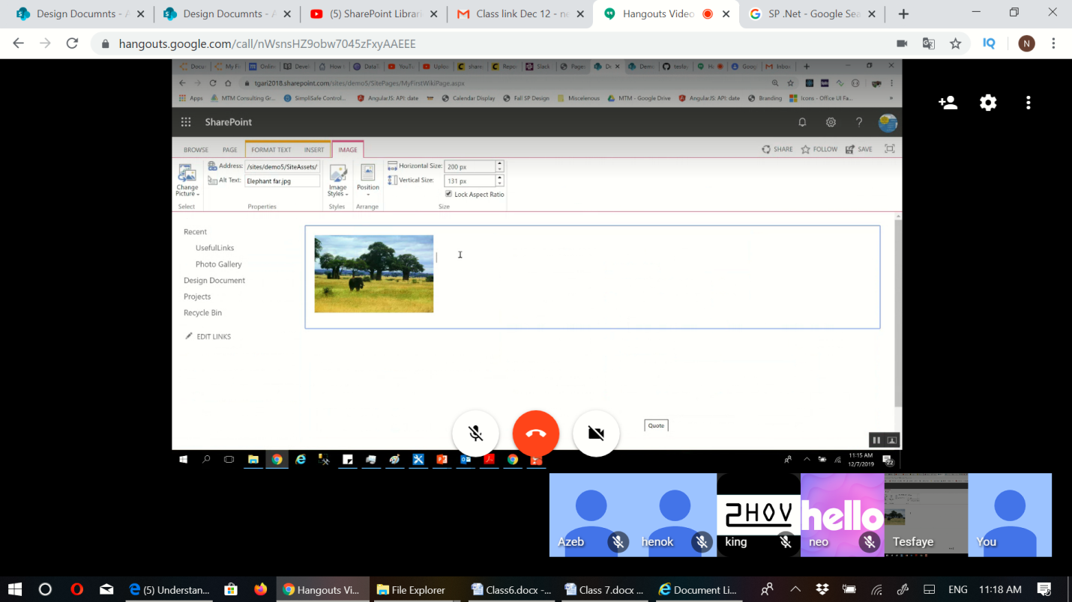

Insert

app

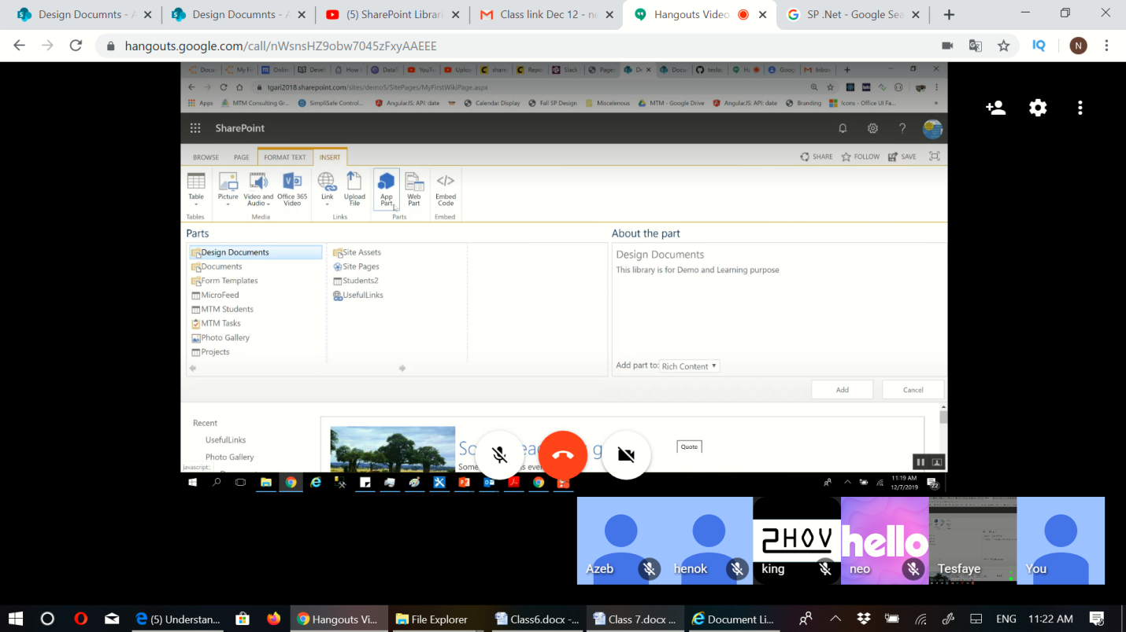

Web part

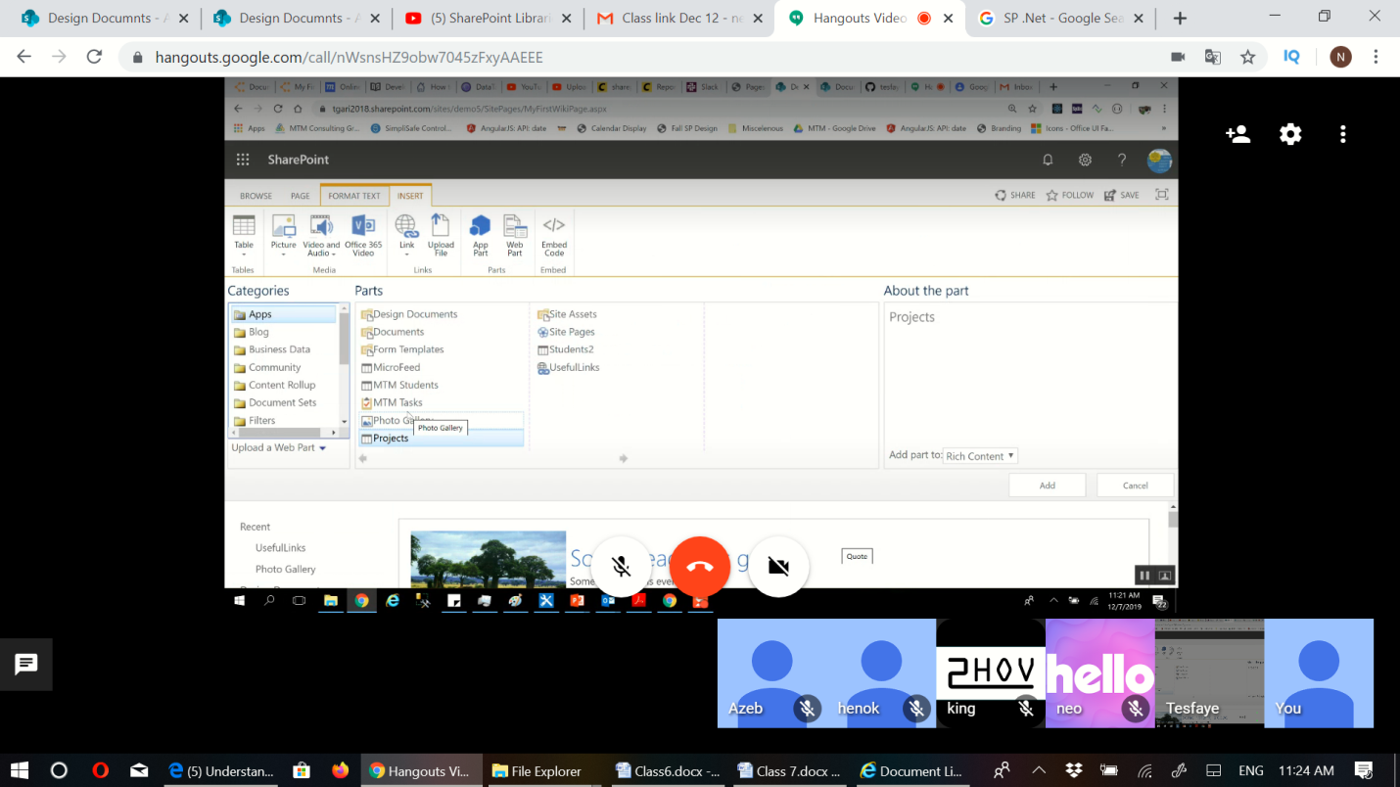

Form text

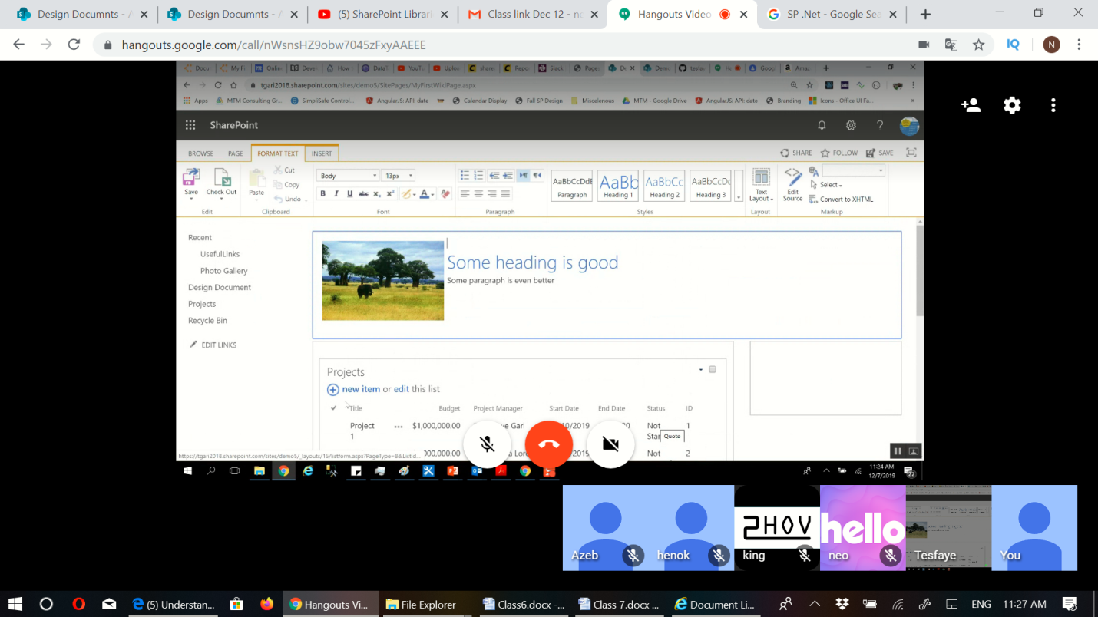

///

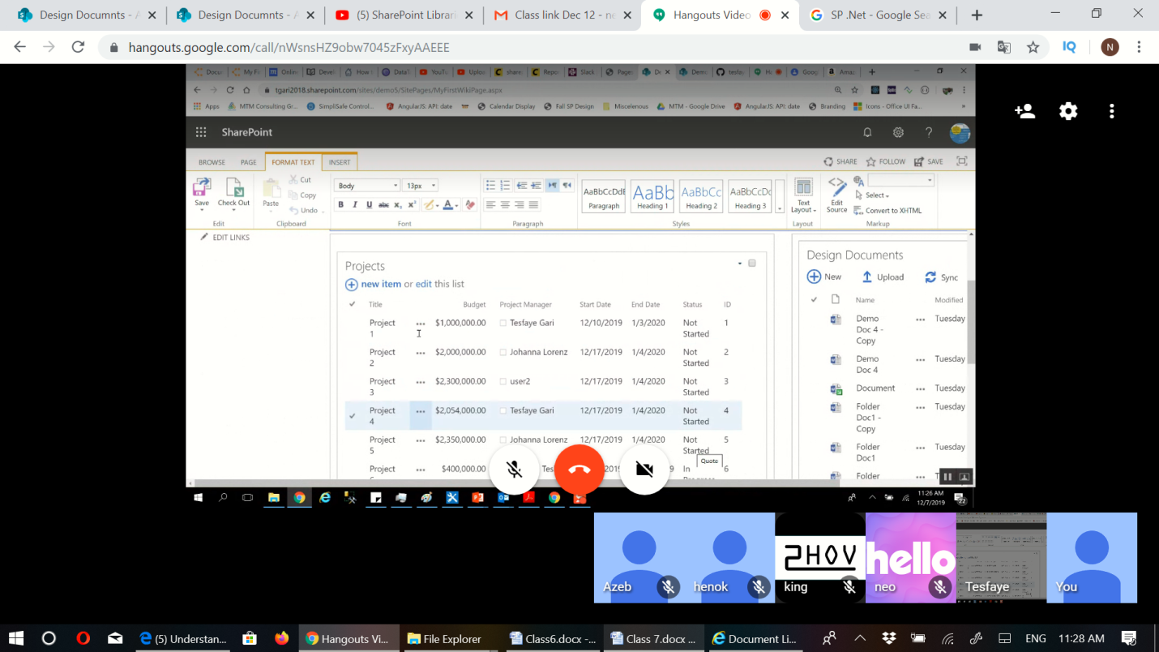

Web part

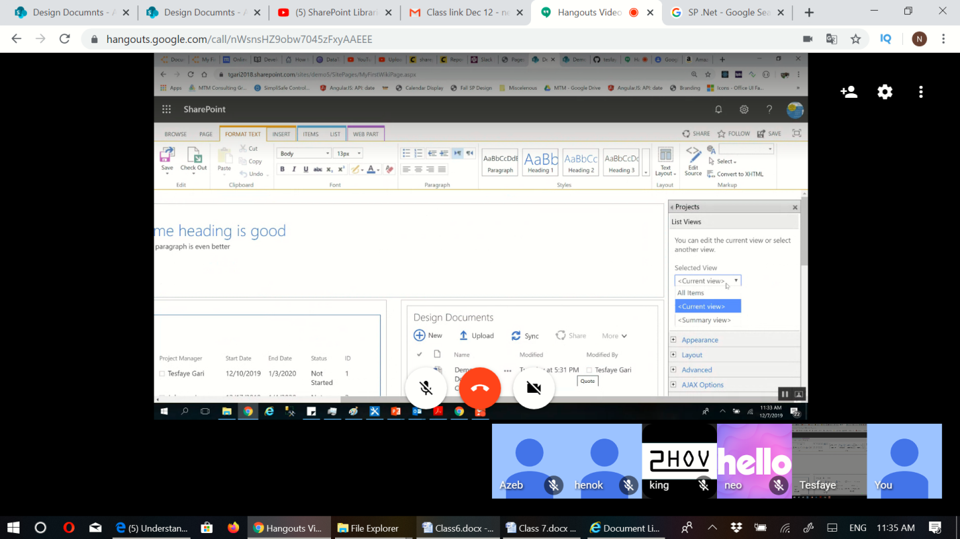

## Site page

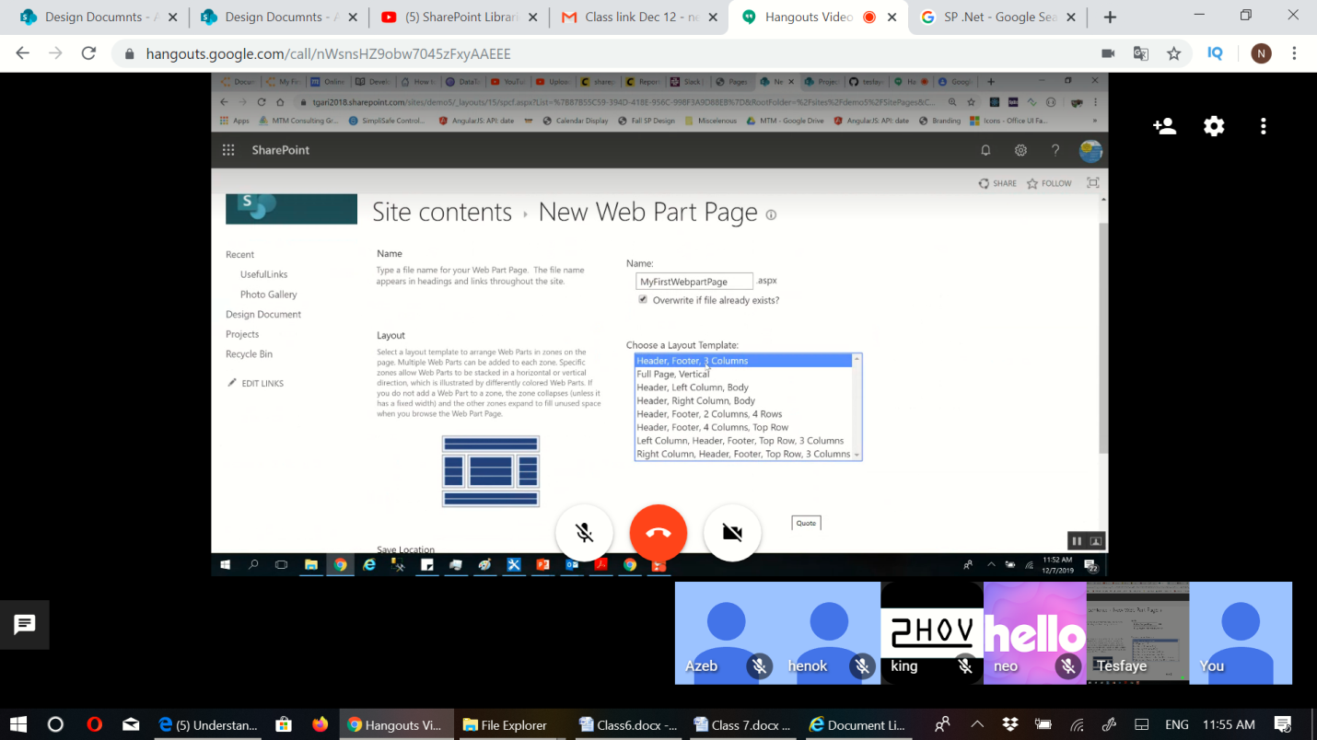

File=>New=>web part

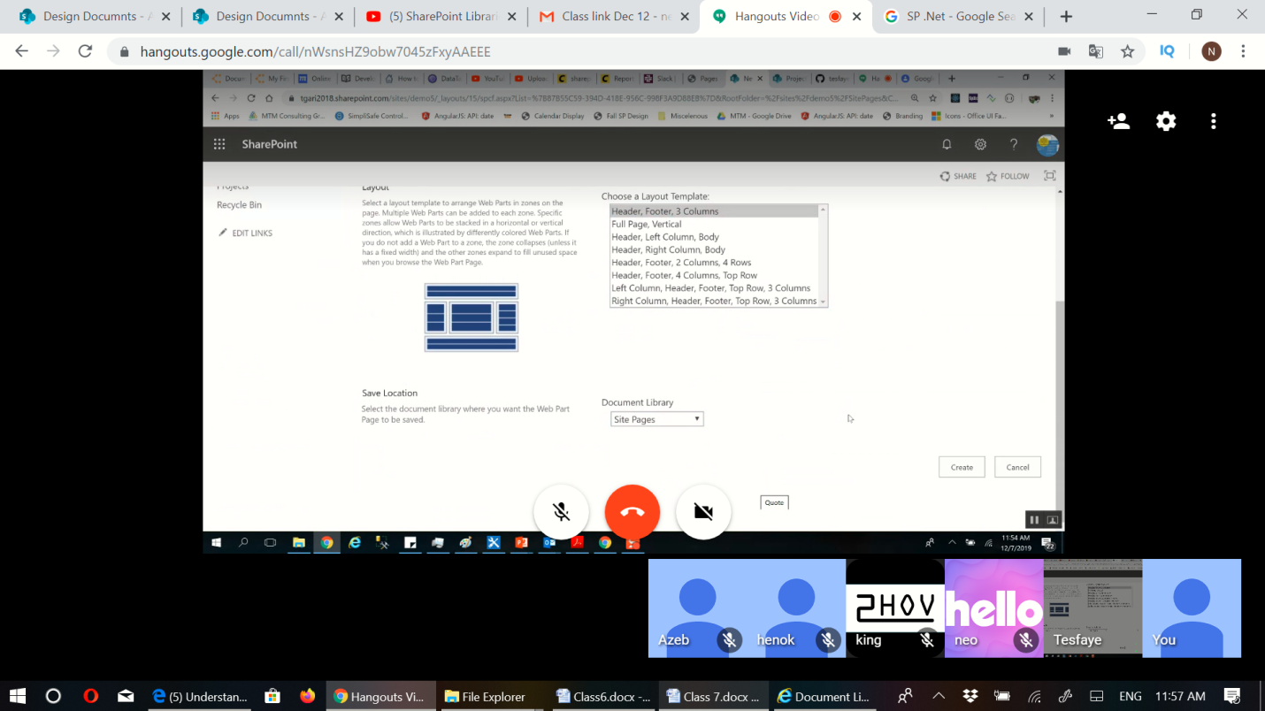

//////

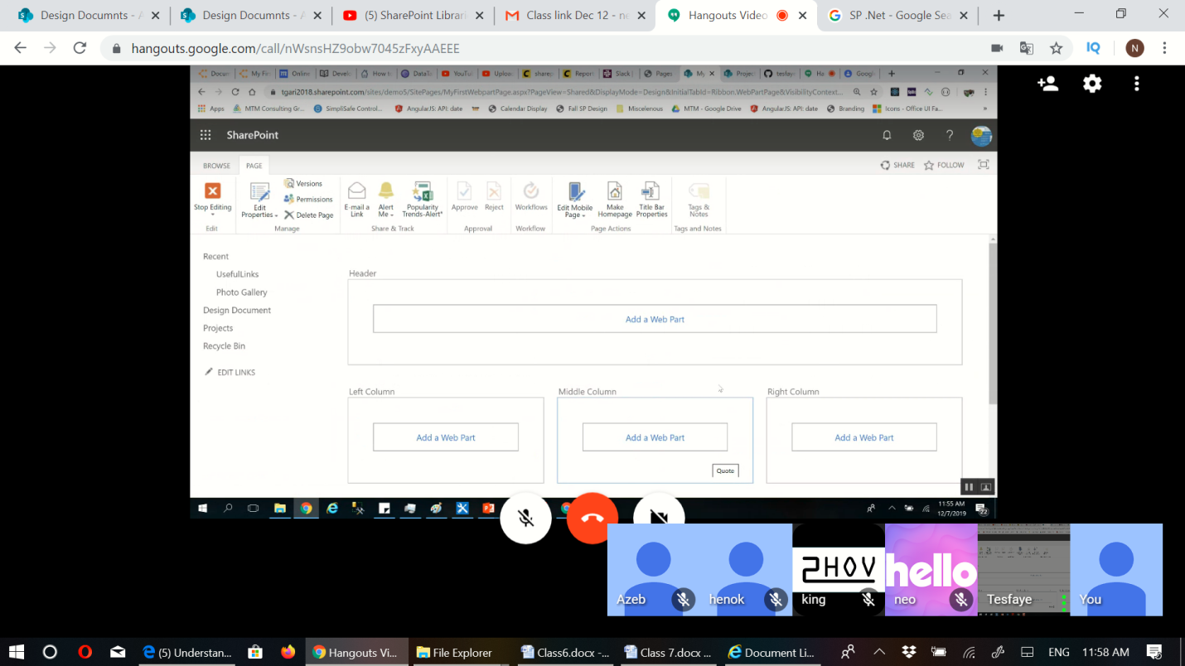

//////

View

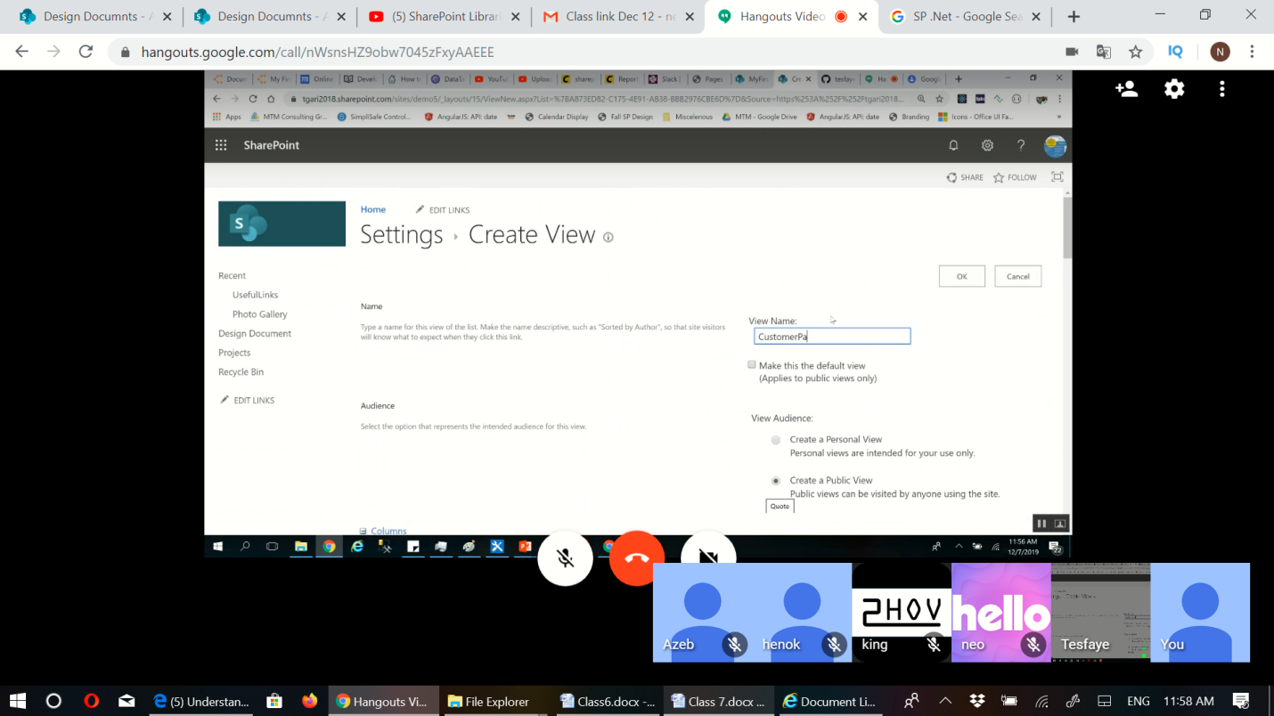

## Download





